CSCI-6461 Computer System Architecture
PROJECT - Part Two – Simulator
Designed by TEAM 6
Owen Chibanda
Deepika Kubendira Rao
Nongxu Li

Execution Instructions
To successfully run the simulator, follow these steps:
- Ensure Java is Installed
  - Verify that you have an updated version of Java installed on your system.
- Download and Extract Files
  - Obtain the ZIP file containing the necessary components.
  - Extract both Project1.txt and the JAR file to the same directory.
- Run the Simulator
  - Open a Terminal or Command Prompt.
  - Execute the following command:
java -jar Simulator.jar
- Load the Input File
  - Once the application launches, click the IPL button.
  - A file selection dialog will appear.
  - Choose Project1.txt and click Open.
  - A confirmation message will indicate a successful file load.
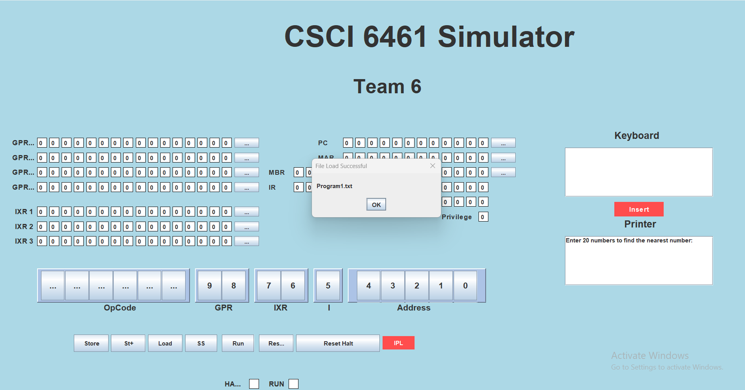

- Enter Data
  - Input up to 20 values using the Keyboard section.
  - Click Insert to add them.
- Find the Closest Value
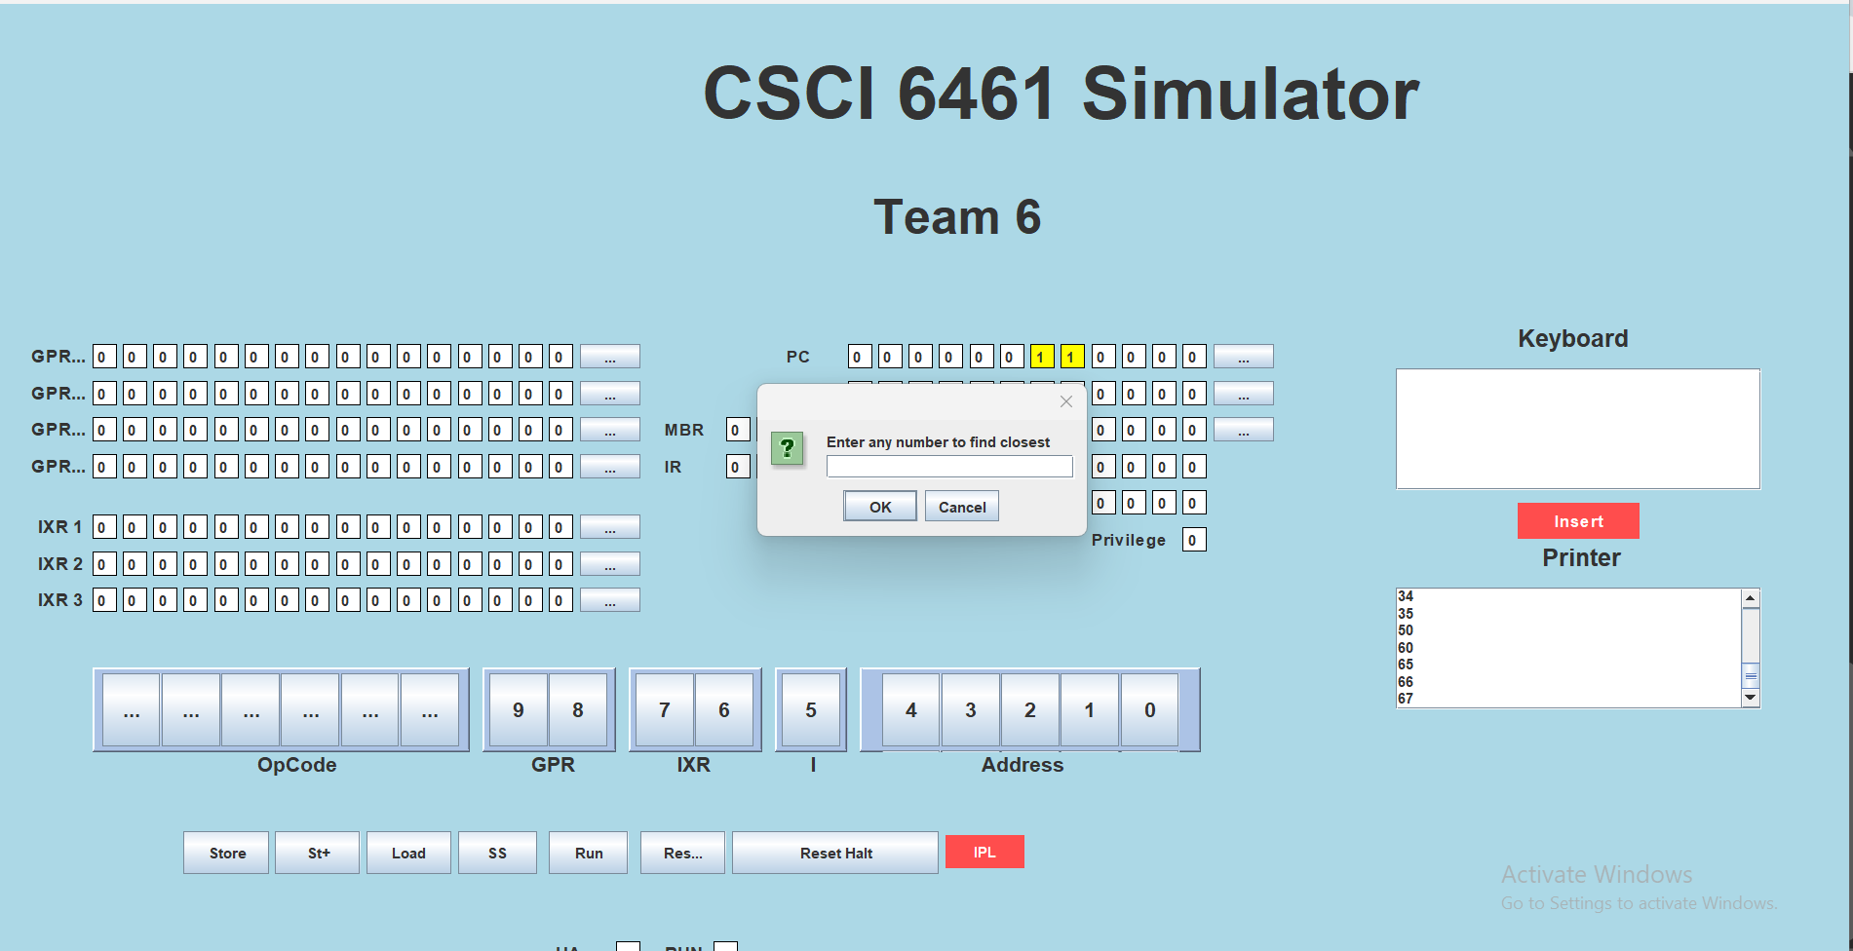
  - After entering 20 numbers, the application will prompt you to enter a target number.
  - Input the number into the pop-up panel.
  - The system will compute and display the closest matching value among the provided inputs.
Example:
  - If you enter 100, and the closest number among the set is 67, the result will be displayed on the Printer screen.

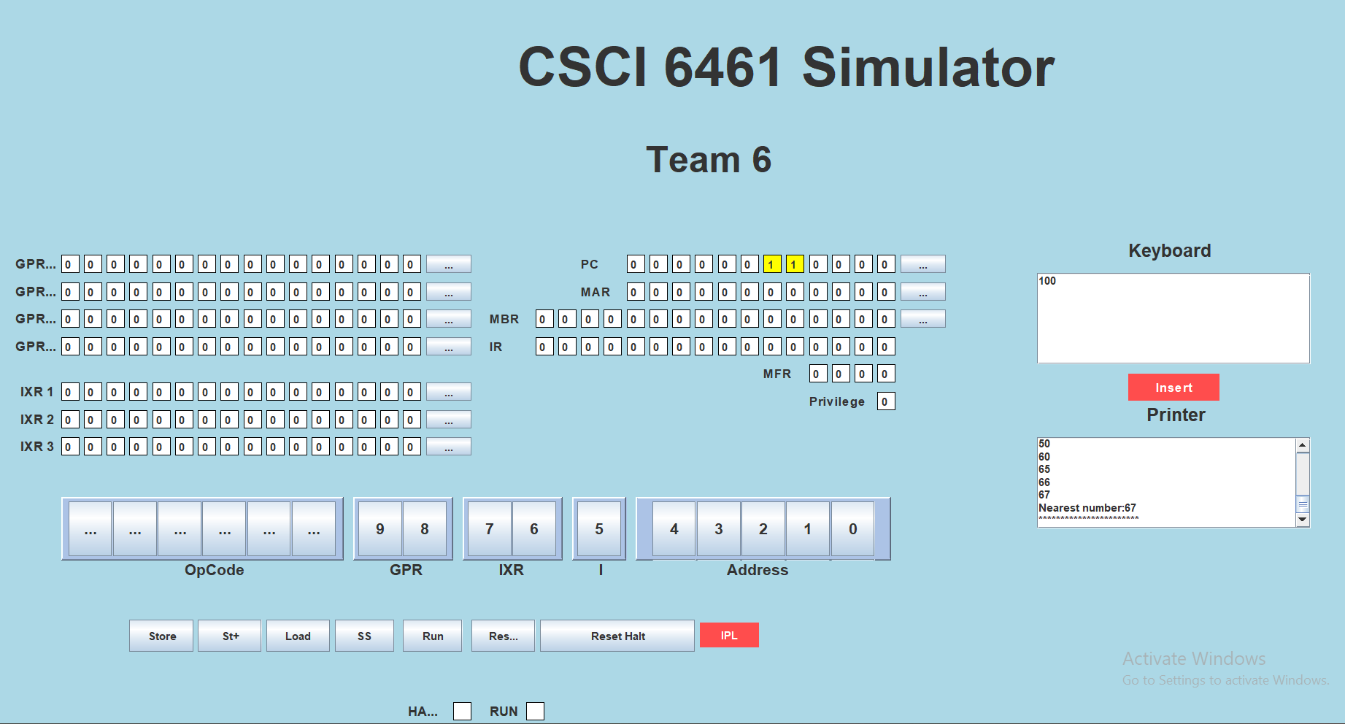

Following these steps will ensure the simulator runs smoothly and provides accurate results.

